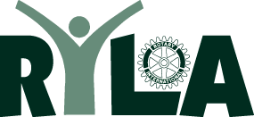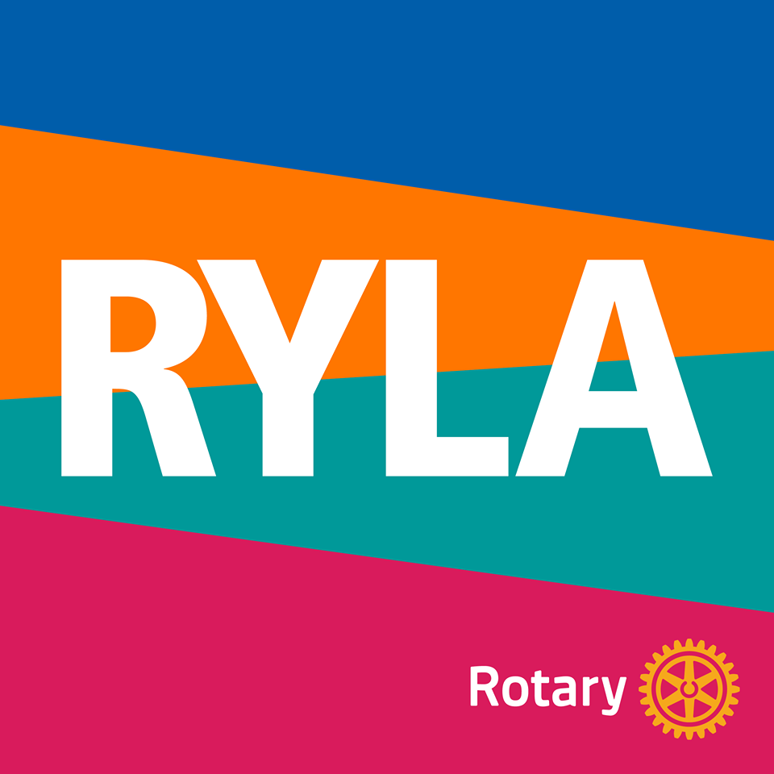
2022 RYLA Club Commitment Form
Please complete this form if your Club is sponsoring students in this year’s District 6580 RYLA Program.
This year’s RYLA will take place at Bradford Woods, Friday, October 21 – Sunday October 23, 2022.
Name of Rotary Club: _____________________________________________
Number of students your club is sponsoring at RYLA:____________________
Club President____________________________________________________
Email________________________________ Phone______________________
The RYLA Contact Person for our club is_______________________________
Address__________________________________________________________
City _________________________ State _____ Zip ________________
Day Phone _____________________Evening or Cell____________________
Email____________________________________________
--------------------------------------------------------------------------------------------Registration fee: $200/student (please make checks payable to Rotary District 6580)
Please return this Commitment Form to the below address by September 1, 2022:
Registration Fee/Checks due to the same address No Later than October 1, 2022
Loren Snyder, RYLA District Chair
1630 N. Delaware St.
Indianapolis, IN 46202
If you have questions, please contact Loren at lasnyder@rwbaird.com or at (317)-407-1837.

